CLOSING CHEAT SHEET

Trial close
- How does that sound to you?
- Does that meet your requirements?
Direct close
- Do you want to go ahead?
- Shall we proceed with the order?
- May I count on your business?
Assumptive Close
- When shall we deliver it?
- Will 20 cases be enough?
- Are you paying for that by card?
Alternative Close
- Would you prefer the red or the blue?
- Do you want the small or the medium size?
- Do you prefer Option A or Option B?
Conditional Close
- If I ring the factory and they have a red one, will you go ahead today?
- If I can train all your staff, will you take this package?
- If I can get you finance, will you choose the premium version?
Columbo Close
- Just one more thing…..why wasn’t I successful today?

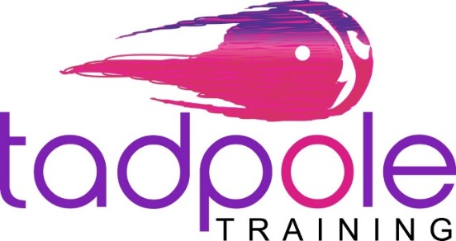

07748 994 334
www.tadpoletraining.com
jefere@tadpoletraining.com

Helping SMEs and entrepreneurs who struggle with sales and who want to sell more authentically, ethically and profitably.

Sales & Marketing Strategy
Sales Training
LinkedIn
Customer Service Skills
Communication
Body Language
Presentation Skills
Telephone Techniques

